Implement Azure Container Instances (ACI)

Lab Objective
In this lab, you will learn how to:
- Deploy a containerized application using Azure Container Instances
- Run a web application without managing servers
- Access the container using a public DNS name
- View container logs for troubleshooting

Business Scenario (Why This Lab Matters)
Your organization:
- Runs applications on on-premises virtual machines
- Wants to move to the cloud
- Does not want to manage many servers
➡ Azure Container Instances (ACI) provides a serverless container platform where you can run containers instantly without managing infrastructure.

Architecture diagram
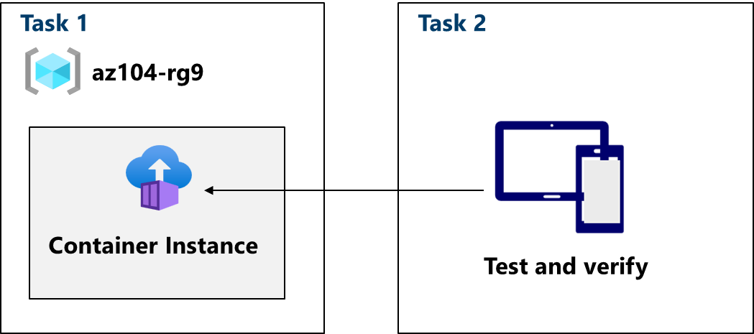

Core Concepts (Understand Before the Lab)

What is a Container?
A container is:
- A lightweight, portable package
- Includes application code, runtime, libraries, and dependencies
- Runs consistently across environments
Containers are faster and smaller than virtual machines.

What is Docker?
Docker is:
- A container platform
- Used to build, package, and run containers
Key Docker terms:
- Image: A read-only template (application + dependencies)
- Container: A running instance of an image

What is Azure Container Instances (ACI)?
Azure Container Instances (ACI):
- Is a serverless container service
- Runs containers without VMs or Kubernetes
- Ideal for short-lived or simple workloads
You don’t manage:
- Servers
- OS
- Scaling infrastructure
You only manage:
- Container image
- CPU, memory, and networking settings

When to Use ACI?
Use ACI when:
- You need quick container execution
- You don’t need orchestration (like AKS)
- Workloads are short-lived or event-driven
- You want minimal operational overhead

ACI vs VM vs AKS (Quick Comparison)
Feature | ACI | VM | AKS
Server management | No | Yes | No
Orchestration | No | No | Yes
Startup time | Seconds | Minutes | Minutes
Best for | Simple workloads | Legacy apps | Microservices

Task 1: Deploy an Azure Container Instance Using a Docker Image

What You Did
- Created a container instance using a public Docker image
- Deployed a simple Hello World web application
- Exposed the container publicly using a DNS name

Key Configuration Definitions

Container Name
Logical name for the container instance resource.

Image Source: Quickstart Images
Prebuilt images provided by Microsoft for testing and learning.

Docker Image Used
mcr.microsoft.com/azuredocs/aci-helloworld:latest
This image:
- Runs a simple web server
- Listens on port 80
- Displays a welcome page

Region
Location where the container runs (East US in this lab).

Networking Configuration

DNS Name Label
- Creates a public URL for the container
- Format:
dns-name-label.region.azurecontainer.io
Example:
az104demo.eastus.azurecontainer.io
This allows browser access without additional configuration.

Monitoring Configuration

Container Logs (Disabled Initially)
- Logs capture:
  - Application output
  - HTTP requests
- Can be enabled or viewed later

Task 2: Test and Verify Deployment

What You Verified
- Container status is Running
- Application is reachable via public DNS
- Web page loads successfully

What Happens Behind the Scenes?
- Azure pulls the Docker image
- Creates a container runtime
- Assigns CPU, memory, and network
- Exposes port 80 to the internet
All without creating a VM.

Viewing Container Logs
Logs show:
- HTTP GET requests
- Application activity
Useful for:
- Troubleshooting
- Monitoring traffic
- Debugging startup issues

